**Migration in Code First Approach**

The Entity Framework has a migration tool that automatically updates the database schema when your model changes without losing any existing data or other database objects. There are two kinds of Migration:

* **Automated Migration**

Using automated migration, you don't have to process database migration manually for each change you make in your domain classes.

Run the ***enable-migrations –EnableAutomaticMigration:$true*** command

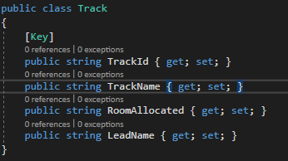

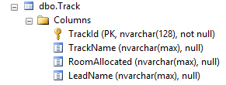

Now when you make any changes in the model classes the same will be reflected in your database.

You can have your property(Column name) modified in your model class(table) by ***Update-Database -force*** command.

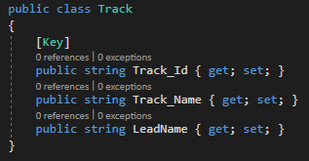

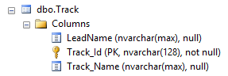

* **Code-based Migration**

Unlike the automated migration this provides more flexibility.

The 3 commands that has to be run in the nuget package console and their functions are given below:

***Enable-Migrations*** Enables the migration in your project by creating a Configuration class.

**PURPOSE OF SEED METHOD**

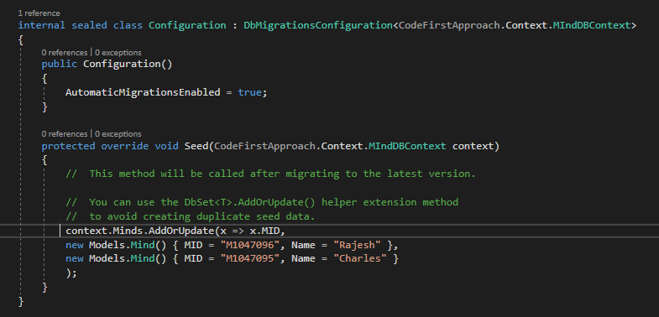

The purpose of the [Seed](https://msdn.microsoft.com/library/hh829453(v=vs.103).aspx) method is to enable you to insert or update ***test data*** after Code First creates or updates the database. The method is called when the database is created and every time the database schema is updated after a data model change.

***Add-Migration migration_name*** Creates a new migration class as per specified name with the Up() and Down() methods.



Up() method is used to create the tables in the database

Down() method is used to alter, delete, drop the tables in the database

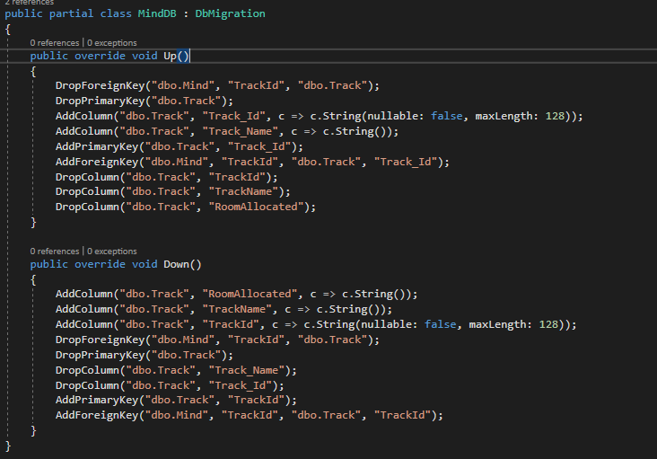

***Update-Database*** Executes the last migration file created by the Add-Migration command and applies changes to the database schema.